**CS 271 Spring 2020**

**Assignment 8**

**Student ID: 014498887**

**Name: Yash Sahasrabuddhe**

**CHAPTER 6**

**Q.2.**

**a)**

The correlation coefficient is used to measure the cluster quality. The adjacency matrix A, of n x n dimensions is defined in such a way that the value of the elements is 1 if two data points belong to the same cluster, or else is 0. There is also a distance matrix D of n x n dimensions, with the elements being the distance between the two data points.

Ideally, if the adjacency matrix element value is 1, then the corresponding distance between the data points must be small and otherwise large. We can define this as, there must be strong inverse correlation between these matrices. This means that the value of rAD = -1. This leads to the clusters being easily differentiable.

**b)**

As we have seen earlier, when rAD = -1, then the clusters are easily differentiable. If rAD 🡪1, then this means that the data points are not differentiable and hence clustering will not be possible.

**Q.4.**

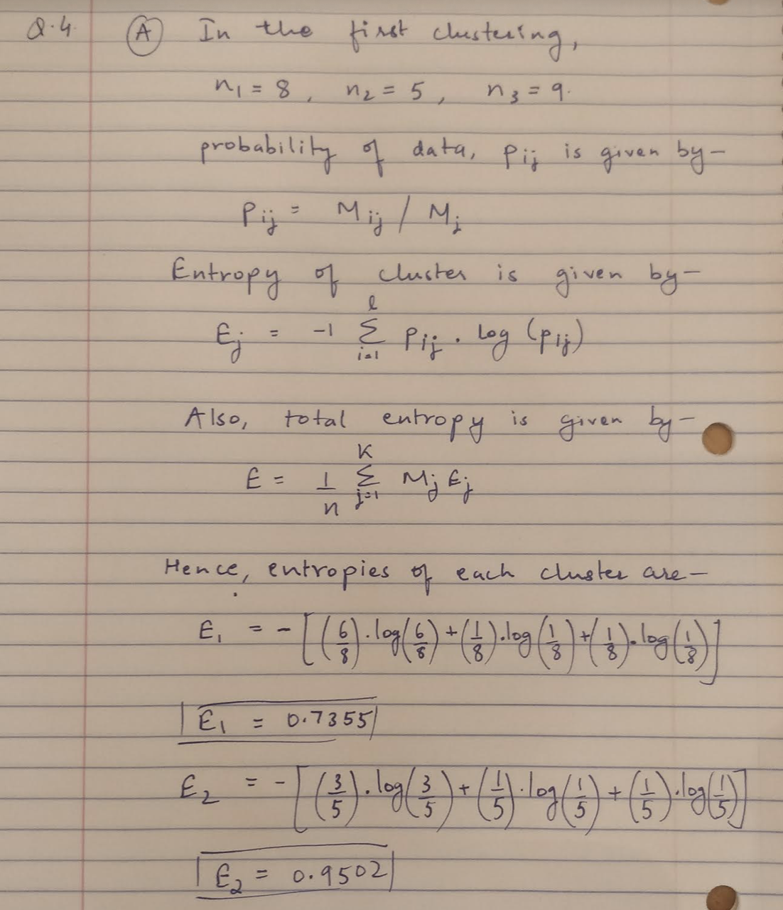

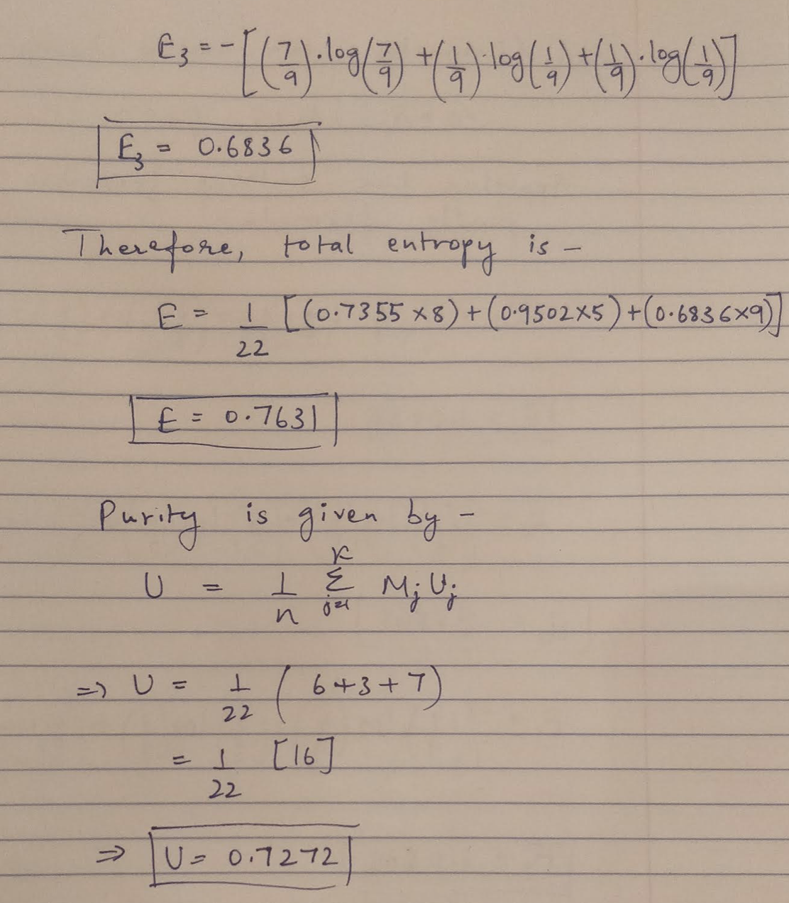

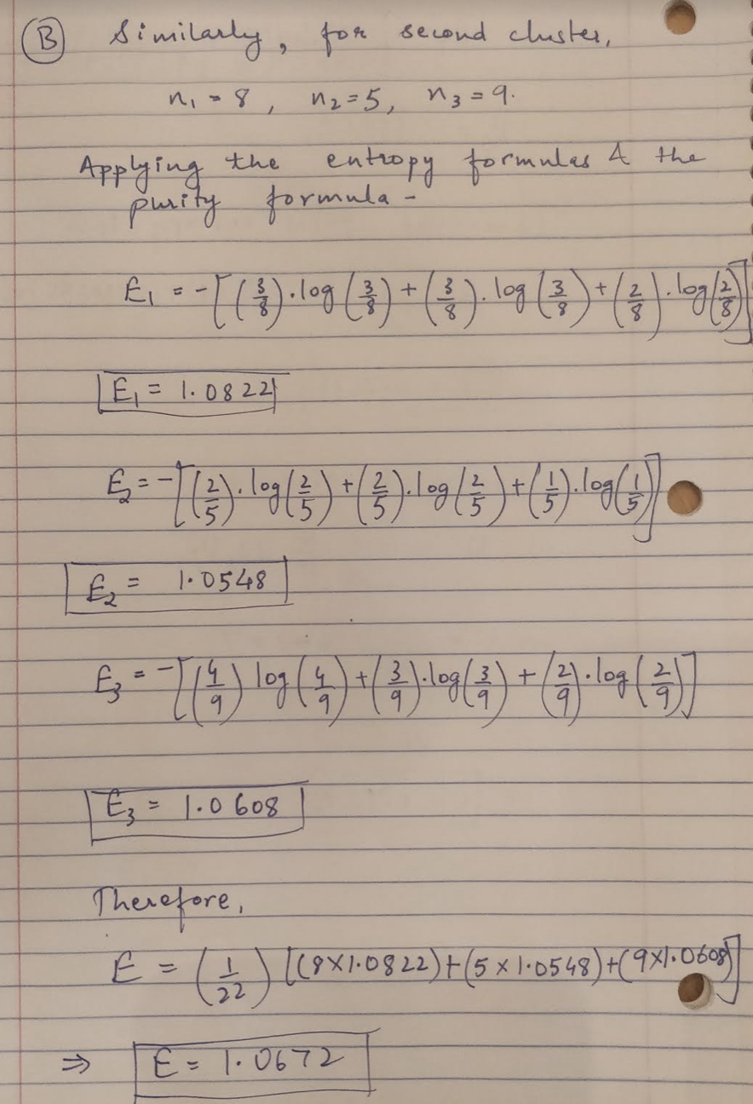

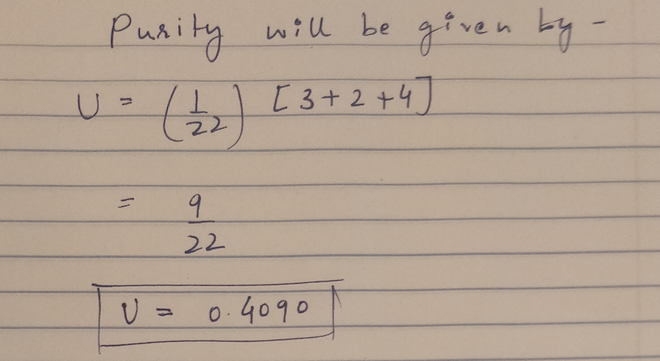

**Q.5.**

1. The source code for this part where the number of clusters, K = 2 is attached with the submission as Q5a.py. The result of the code is a plotted graph where points are assigned to cluster. The output is –

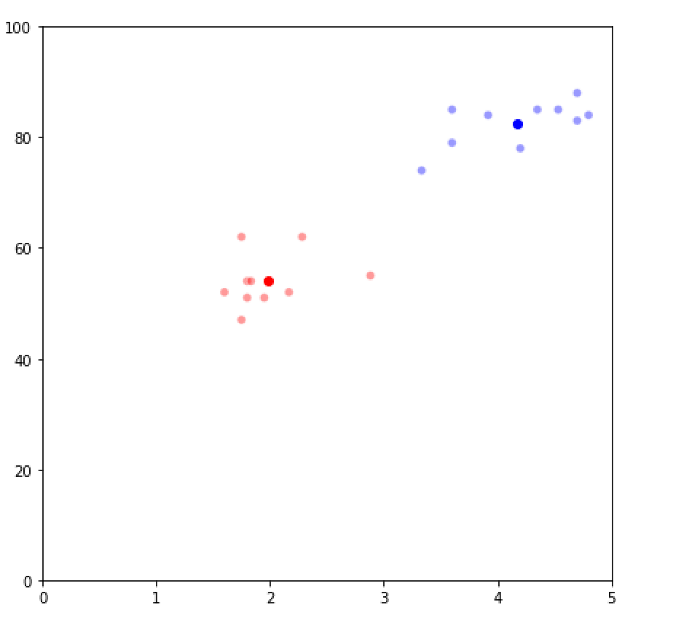

1. The source code for this part where the number of clusters, K = 3 is attached with the submission as Q5b.py. The result of the code is a plotted graph where points are assigned to cluster. The output is –

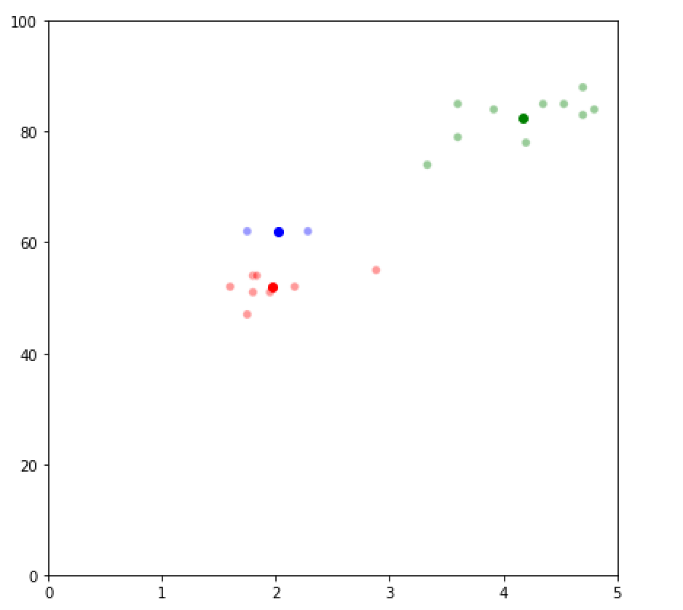

**Q.7.**

The probabilities for the next E step in the coin flip example is calculated using the program Q7.py which is included in the submission. The output of the code is –

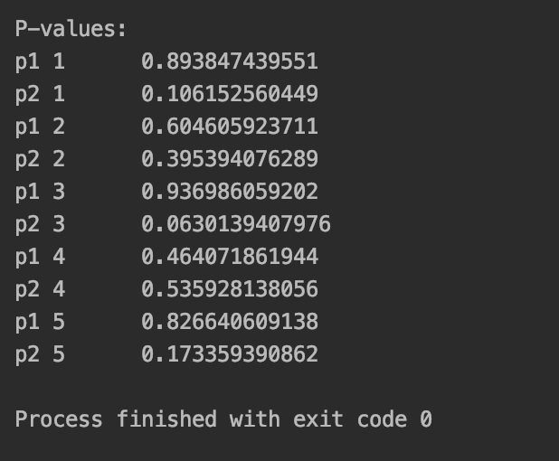

**Q.8.**

1. Using the same initializations for values of 𝜽 & 𝝉, the EM algorithms converges to the same values of 𝜽, that is 0.7934 & 0.5139 respectively. The source code for the EM algorithm is included in the submission as Q8a.py. The output of the code is as below –

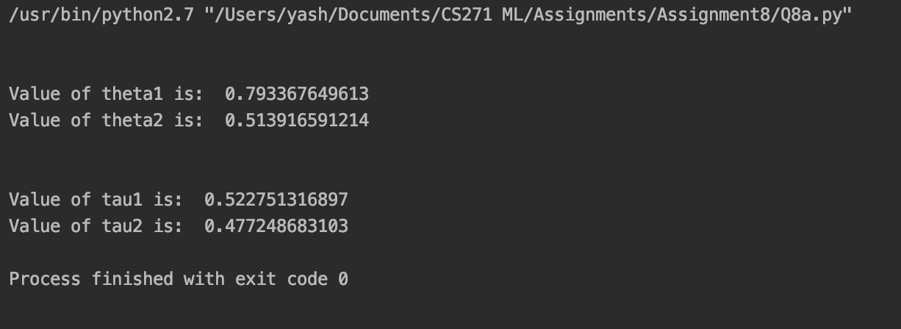

1. Using 3 different initializes, after executing the codes for multiple iterations, **each initialization results converge to the same values** of 𝜽 & 𝝉, that is, to the same values of 𝜽 - 0.7934 & 0.5139 and 𝝉 - 0.5227 & 0.4772. However, there is an interesting catch to the convergence of values of 𝝉 and 𝜽 that the dominating probability of 𝝉 and 𝜽 converges to the higher value. This means that if in one case, 𝝉1 > 𝝉2, or 𝜽1> 𝜽2 then the converged value of 𝝉1 and 𝜽1 will be greater and if 𝝉2> 𝝉1 or 𝜽2> 𝜽1, then the converged value of 𝝉2 and 𝜽2 will be greater. The code for the same is attached with the submission as Q8b.py and the output is also attached below –

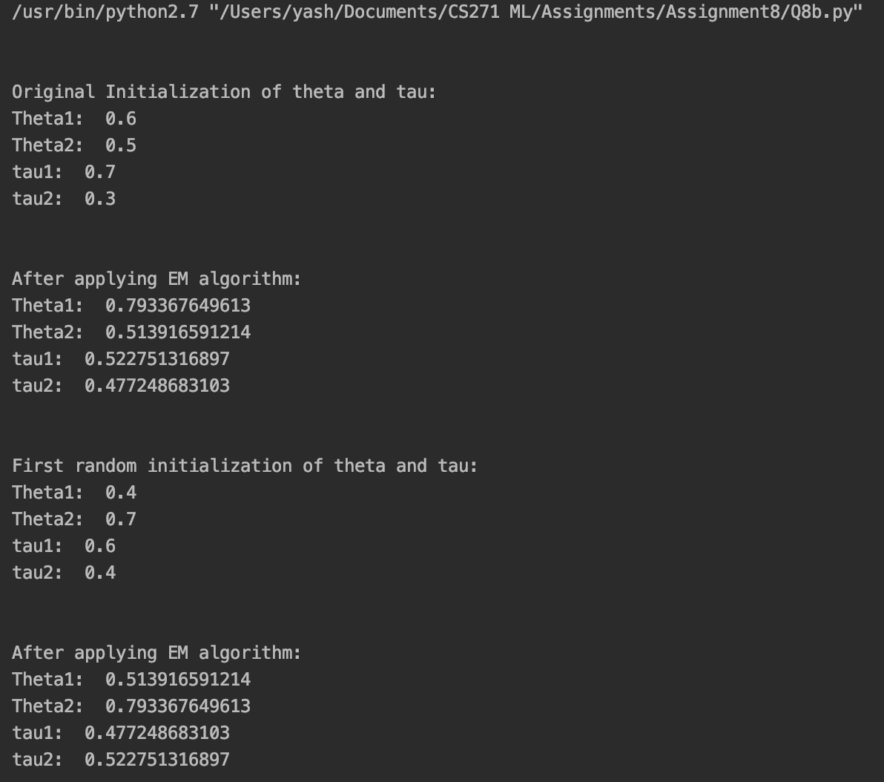

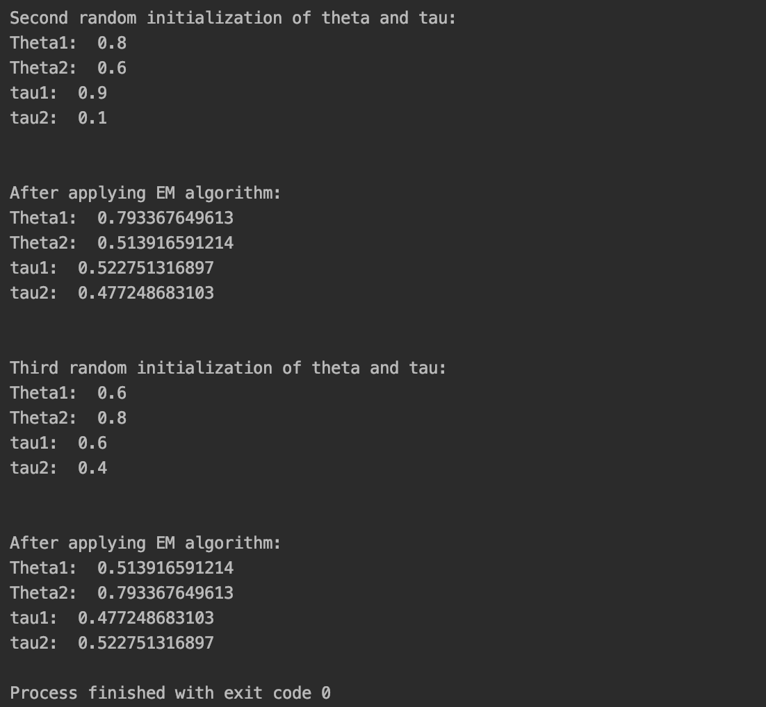

**Q.13.**

1. & **b)** The source code for these sub-parts are included in the submission as Q13ab.py in the Chapter 6 sub-folder. The output of the code is-

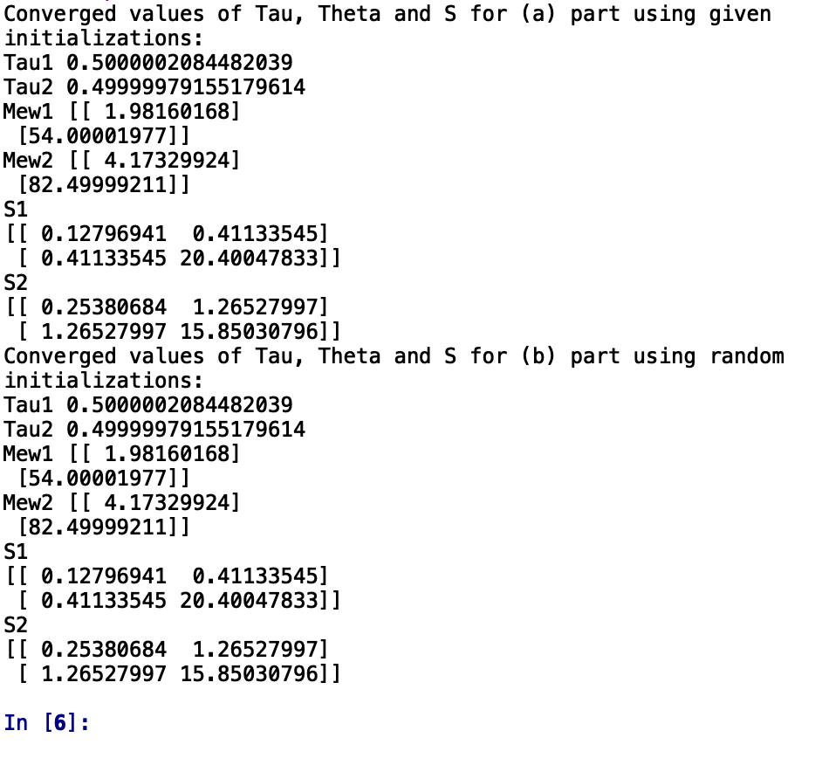

1. The source code for this is included in the submission as Q13c.py in the Chapter 6 sub-folder. The output of the code is-

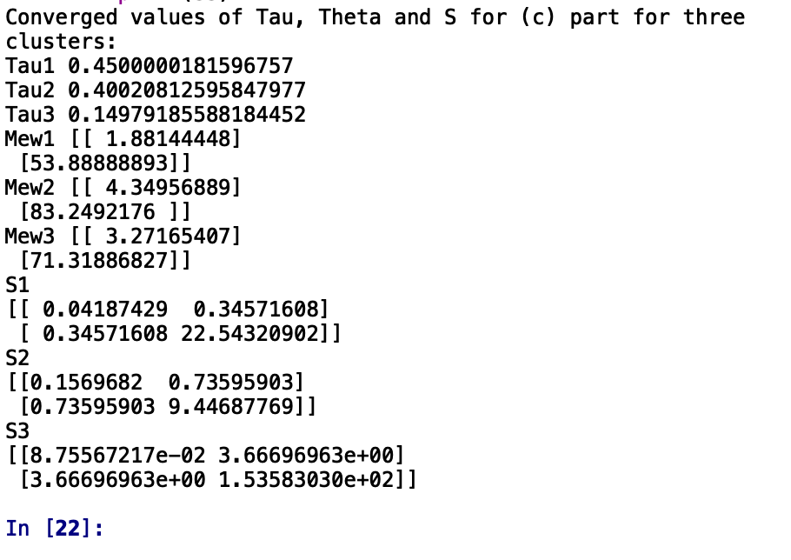

1. The graph achieved in Q5 part (a) is very similar to the graph achieved using EM clustering. The centroids are not exactly same, but the points assigned to the clusters in both the cases is same. The source code for this is included in the submission as Q13c.py in the Chapter 6 sub-folder. The output of the code is-

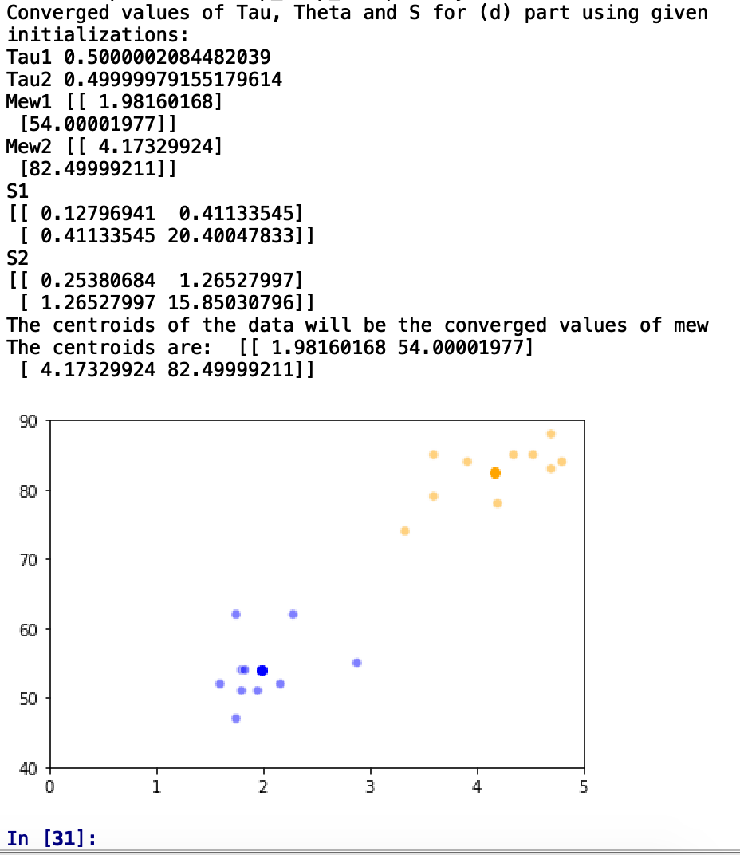

**Q.16.**

1. A point is marked as visited first at the time of cluster formation. These visited points can be added to the clusters if the distance between the visited point and a core point is less than the epsilon value defined.
2. If the point X is at an equal distance from multiple core points, then the point will be added to the last cluster in the iteration. Hence, if the order of cluster iteration changes, then the point X can be assigned to different clusters.
3. The source code for this part is added with the submission in the Chapter 6 codes folder as Q16.py. The graphs for different initializations of m and epsilon are the outputs as below: -

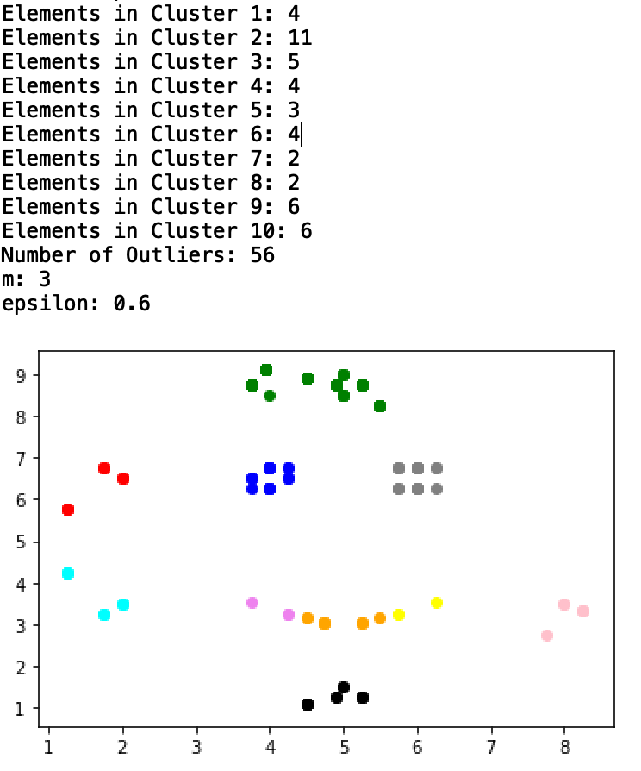

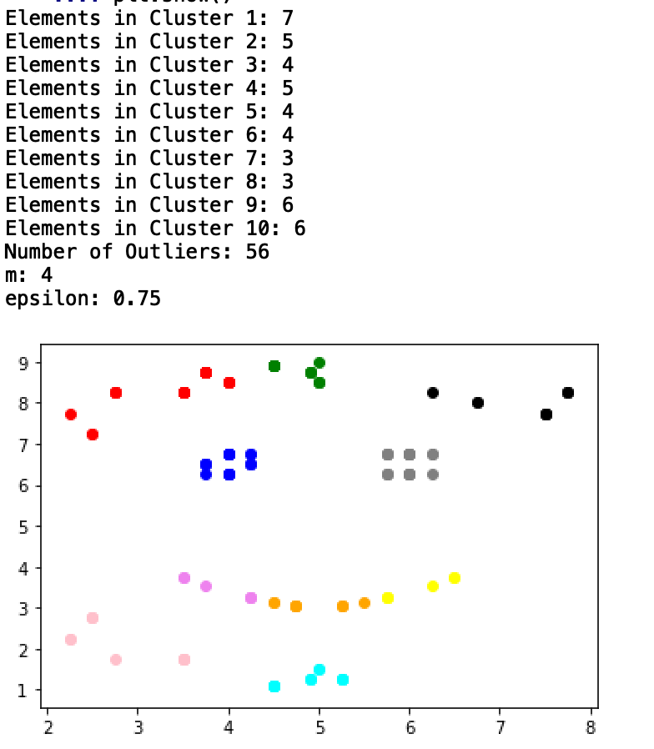

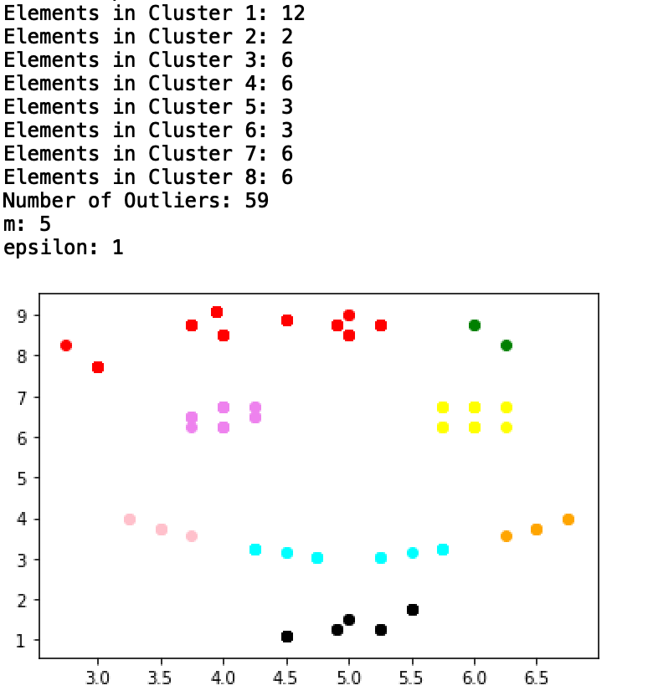

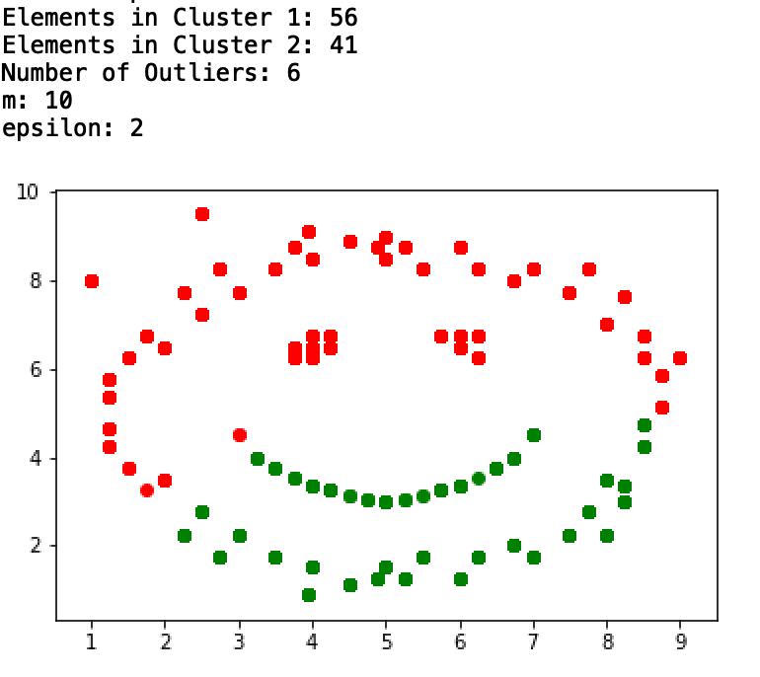

**CHAPTER 7**

**Q.1.**

The source code for this question has been added with the submission in the respective folder of chapter 7 with file name as Q1.py. The plotted output graph of the code is-

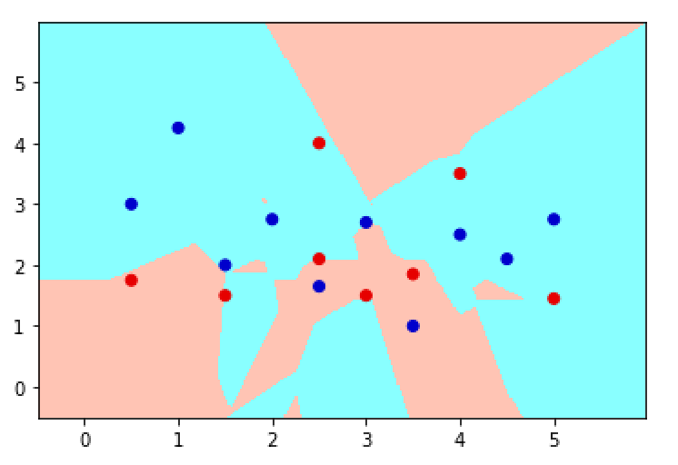

**Q.4.**

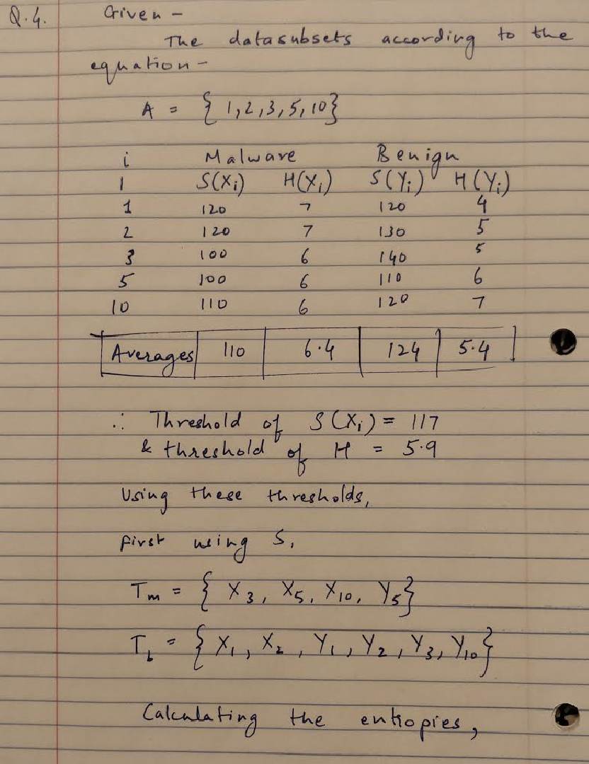

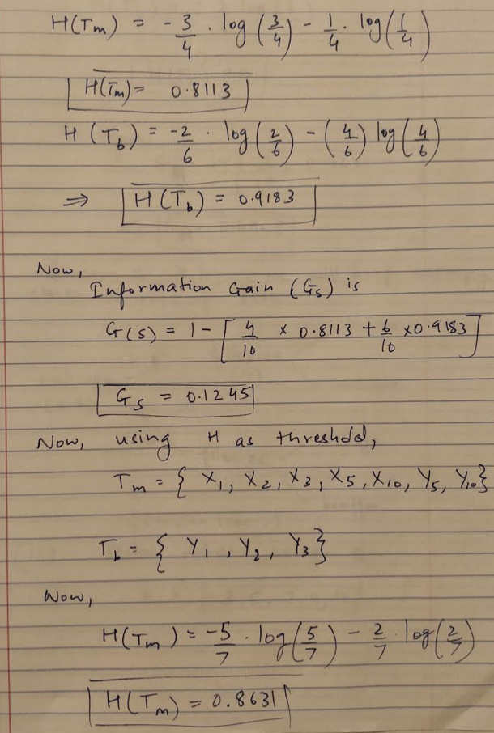

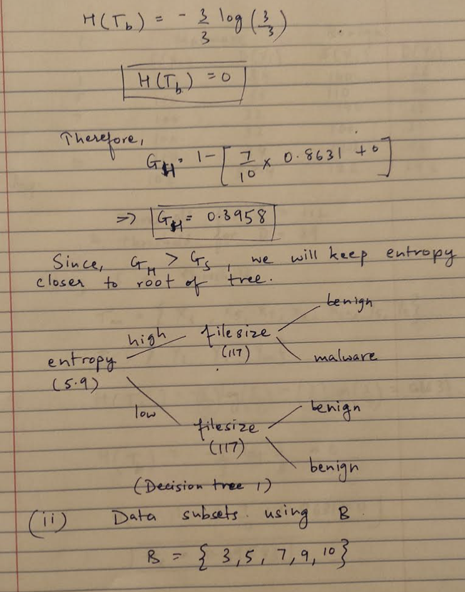

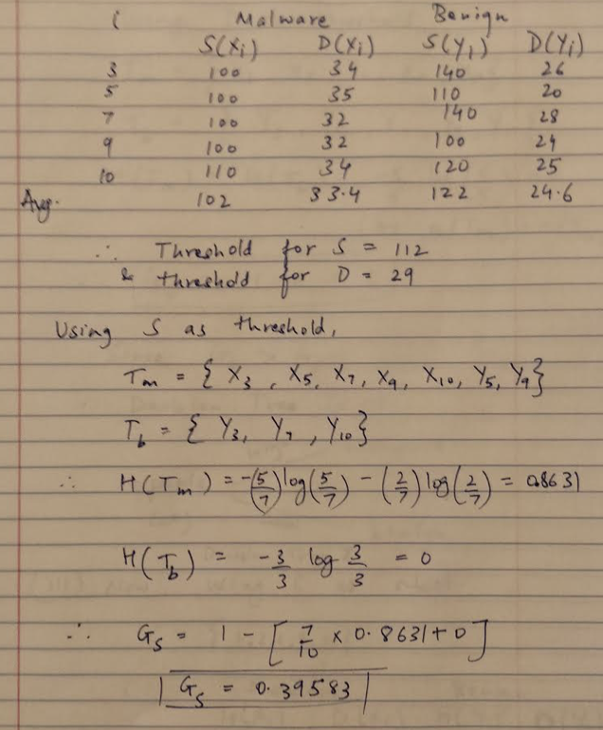

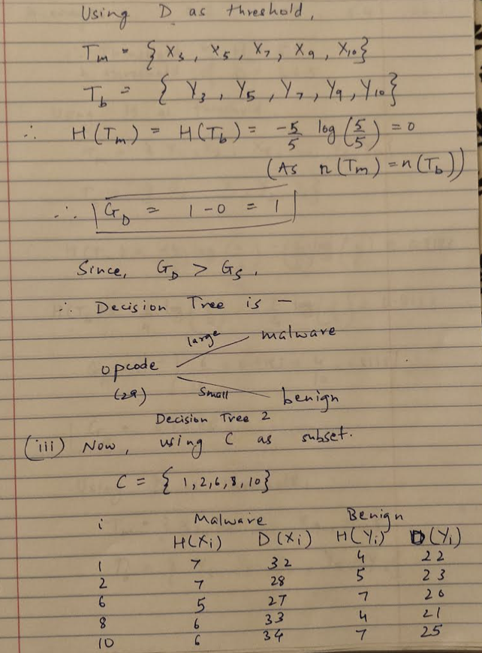

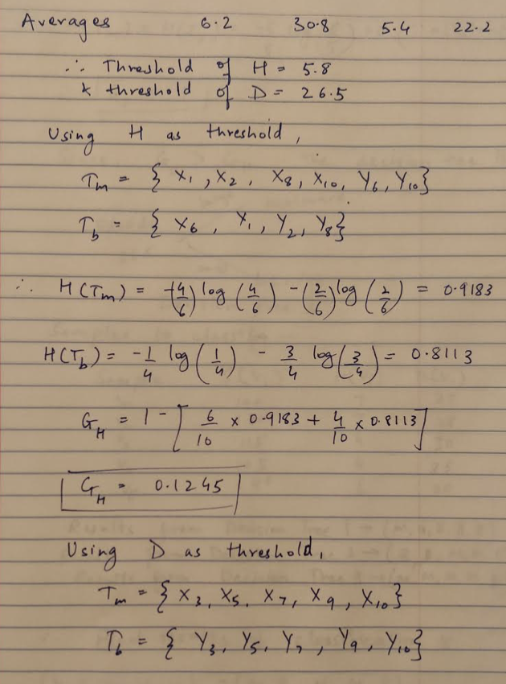

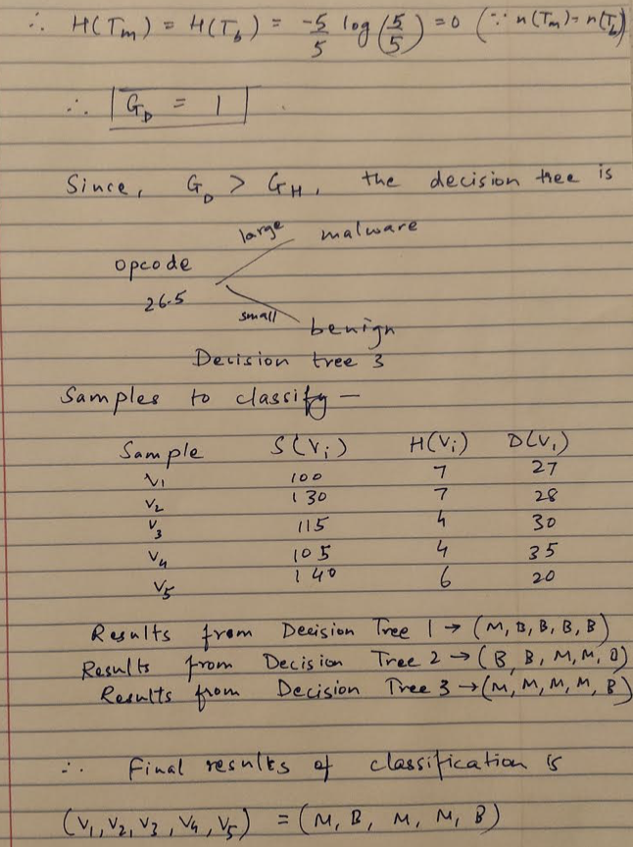

**Q.7.**

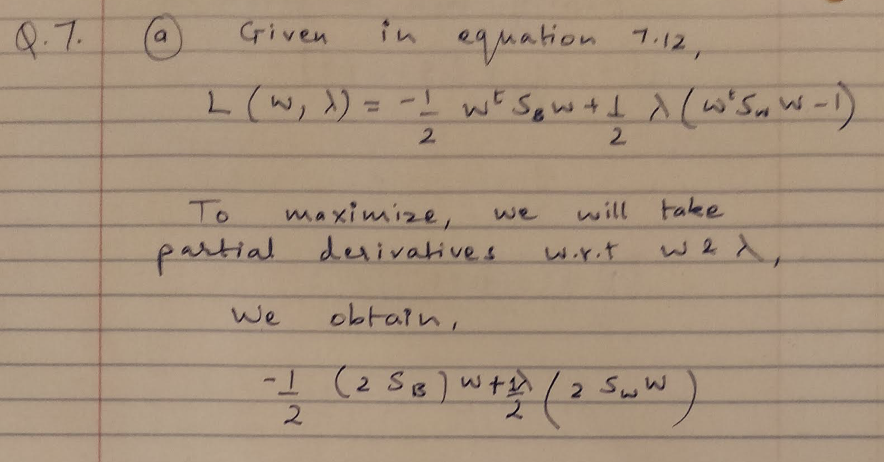

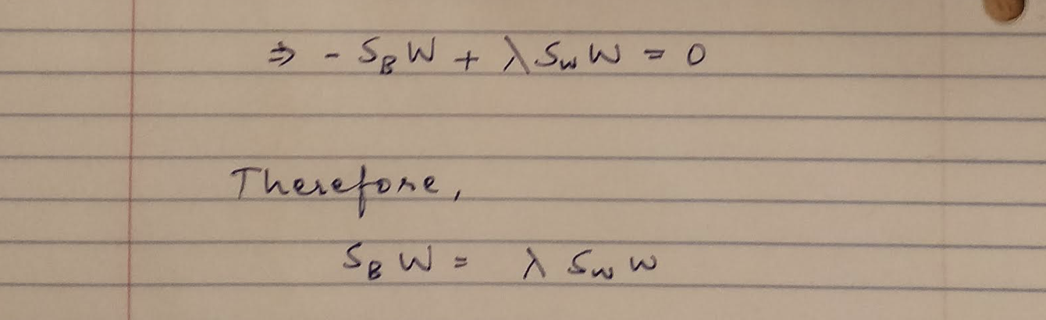

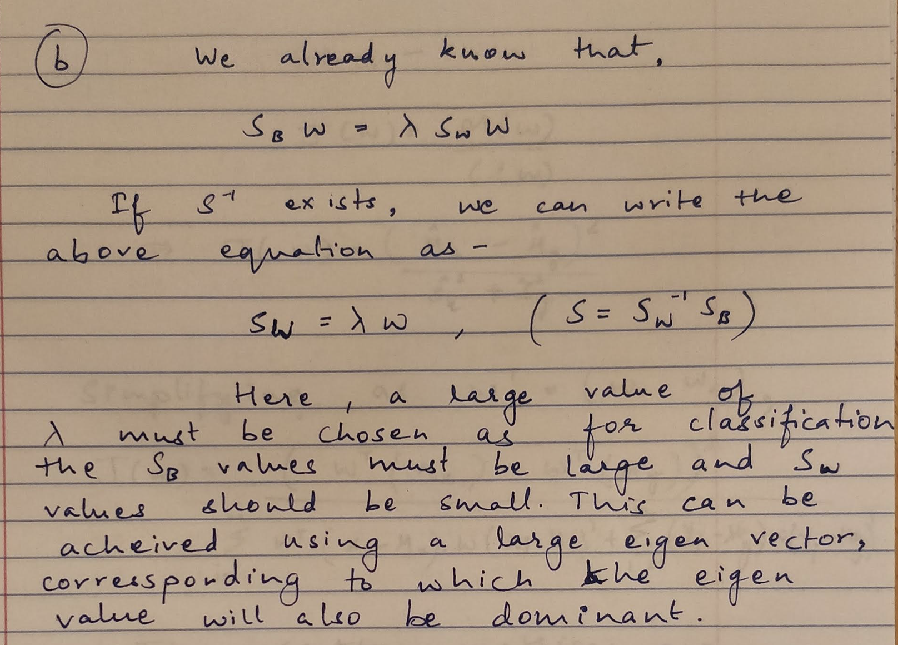

**Q.11.**

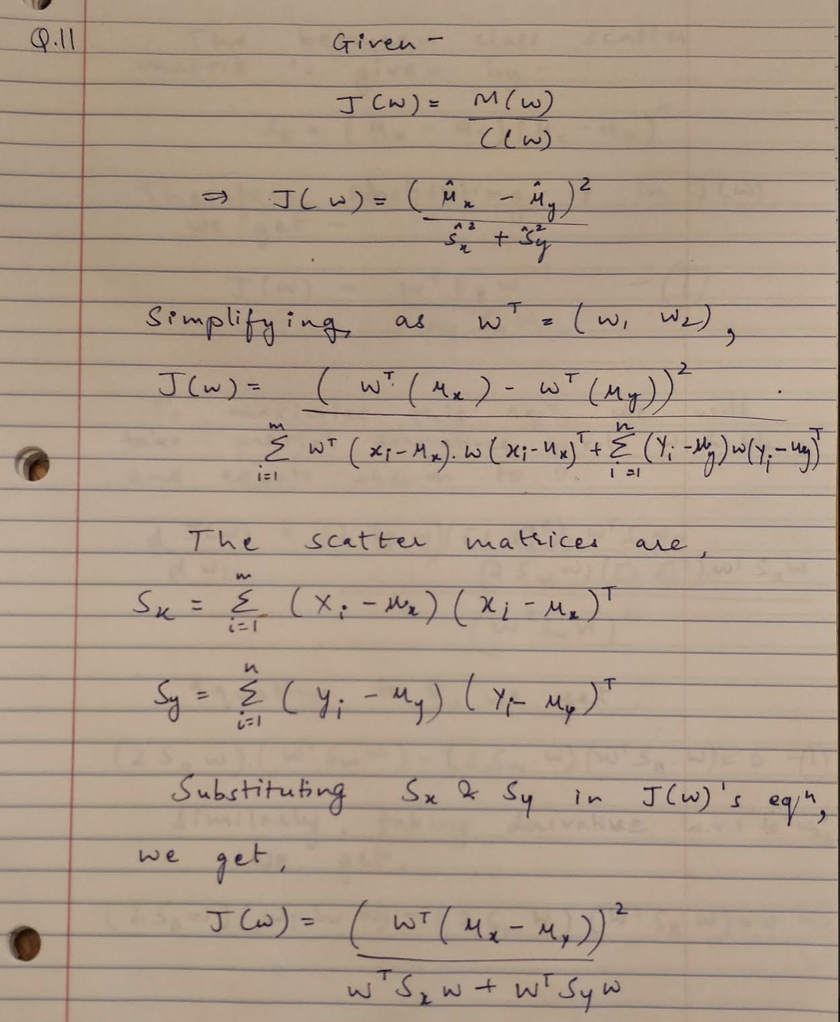

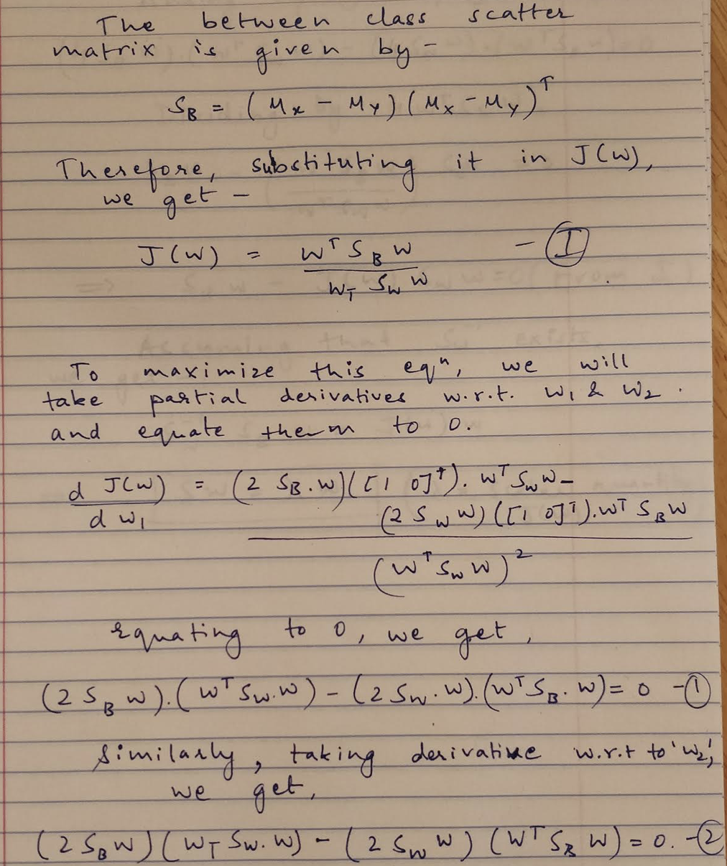

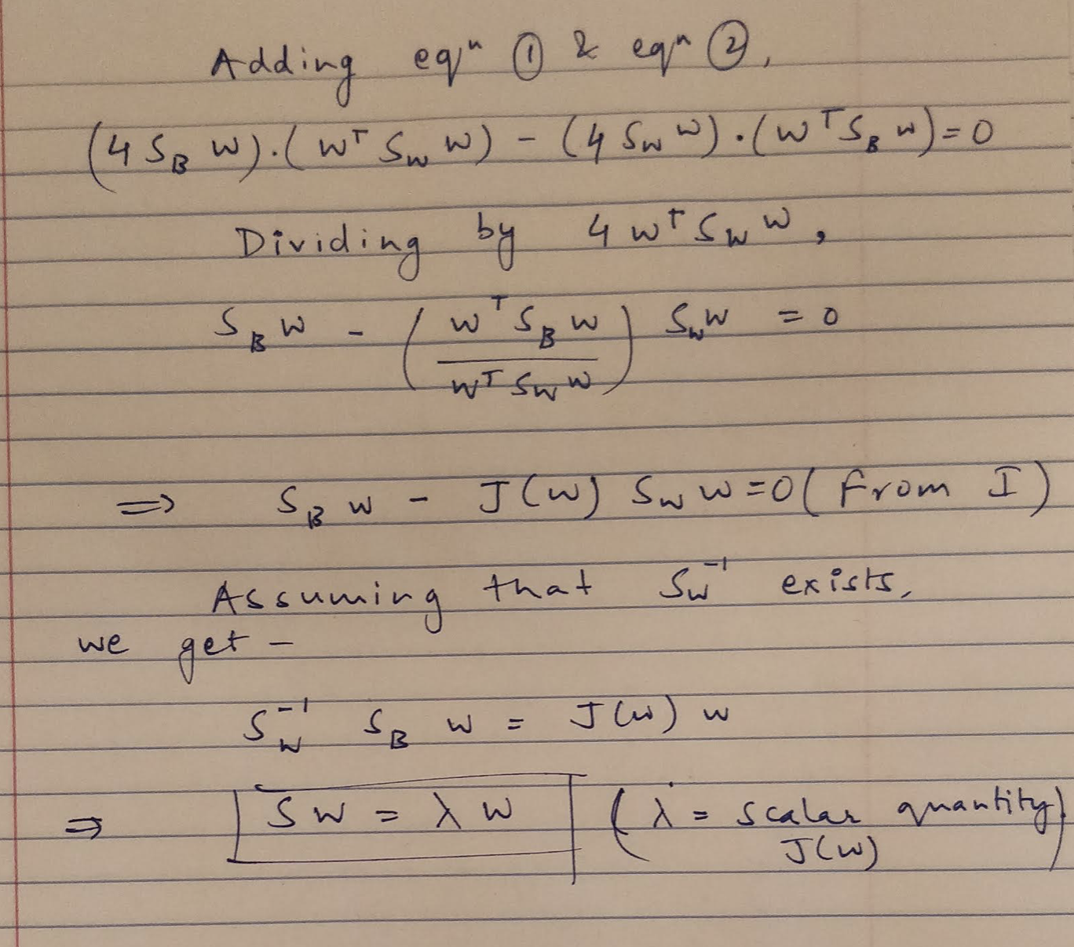

**ADABOOST**

**Q.2.**

The source code for this question is included in the submissions in the AdaBoost sub-folder as adaboost.py. The output of the source code is-

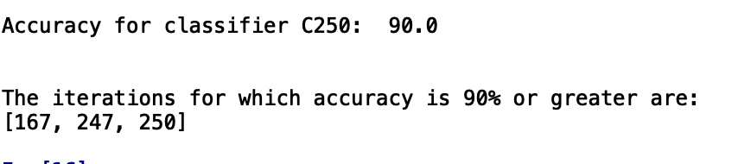

**Note-** Discussed the homework questions with Aditi Walia, Akshay Kajale, Hardik Trehan, Harshit Trehan.